**Installation instructions for software tools described in the supporting information**

For the readers convenience, we provide illustrated instructions for obtaining and installing the free software described in the Supporting Information to be used on various platforms to complete the molecular dynamics simulations. These instructions are organized as follows:

1. Instructions for installing PuTTY on Windows
2. Instructions for installing WinSCP on Windows
3. Instructions for installing VMD
4. **Instructions for Installing PuTTY SSH client**
5. To access PuTTY, visit [www.putty.org](http://www.putty.org) and click on the hyperlink **here** under the **Download PuTTY** heading

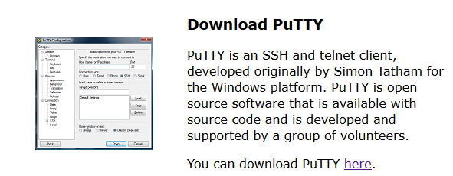

1. On the **PuTTY Download Page**, scroll down to the **Binaries** section (background is green) and click on the **putty.exe** link to download the executable file

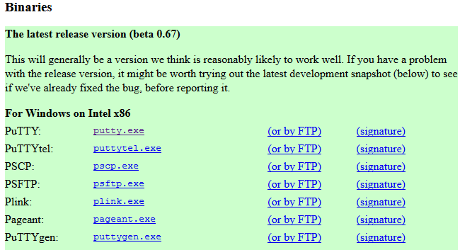

1. Once the download is complete, open the executable file to reveal the **PuTTY Configuration** box

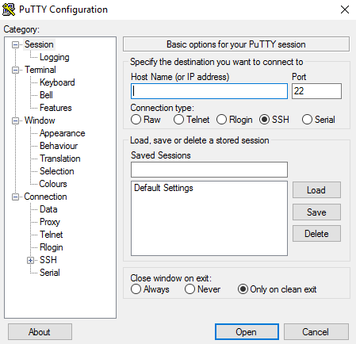

1. Enter the Hostname or IP address of your workstation or cluster into the **Host Name** box and click the **Open** button to enter the Linux environment

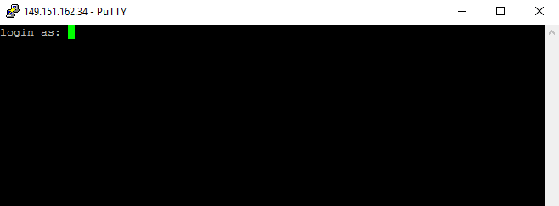

1. Type in your username and press ENTER

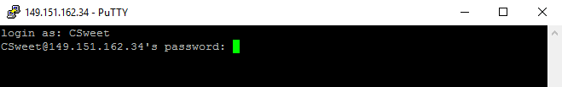

1. Type in the case-sensitive password and press ENTER (note: no text will appear while typing
2. Instructions for installing WinSCP on Windows

WinSCP may be used to transfer the output file from the Linux workstation you are remotely connecting to your own computer so that it can analyze the output of your simulation locally, for example, by animating your MD trajectories using VMD.

1. visit [**https://winscp.net/eng/download.php**](https://winscp.net/eng/download.php) to download a file transfer program, WinSCP

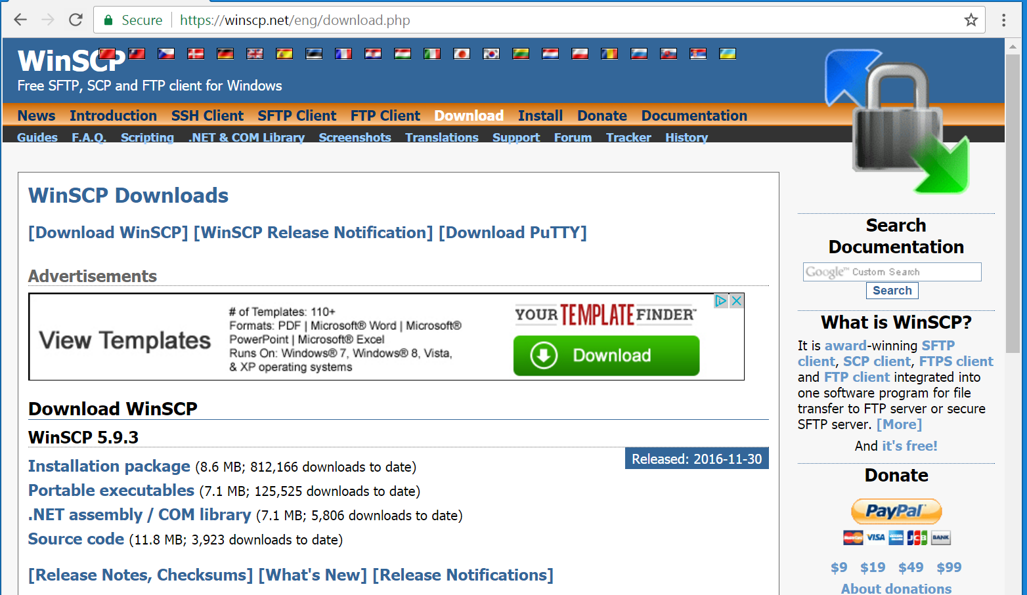

1. Under the **Download WinSCP** heading, click **Installation package** to be redirected to the automatic download page

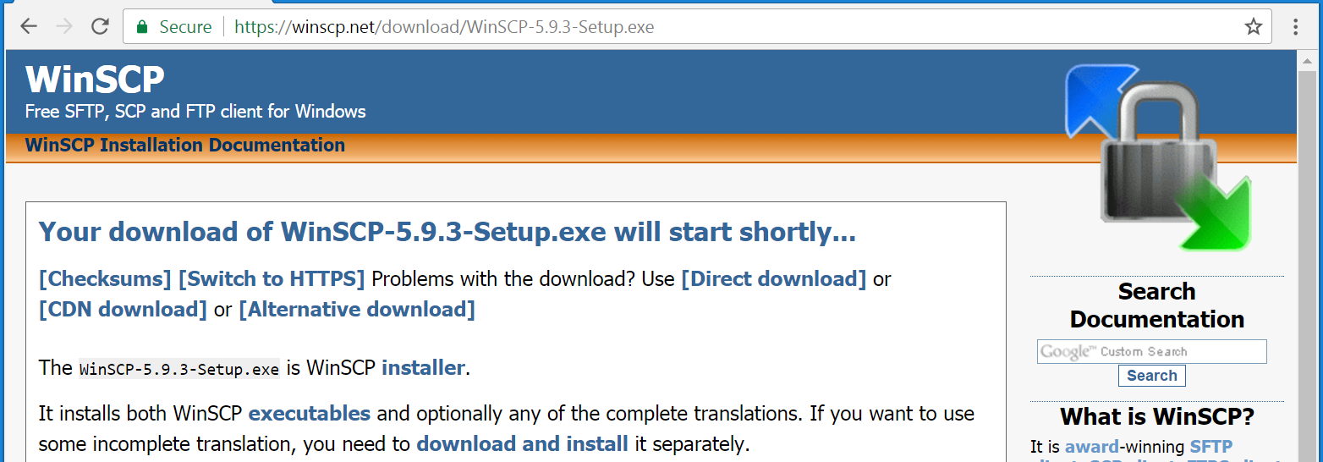

1. Once the download is complete, run the executable file and follow the instructions on the setup wizard using the two-panel **Commander** window view setting

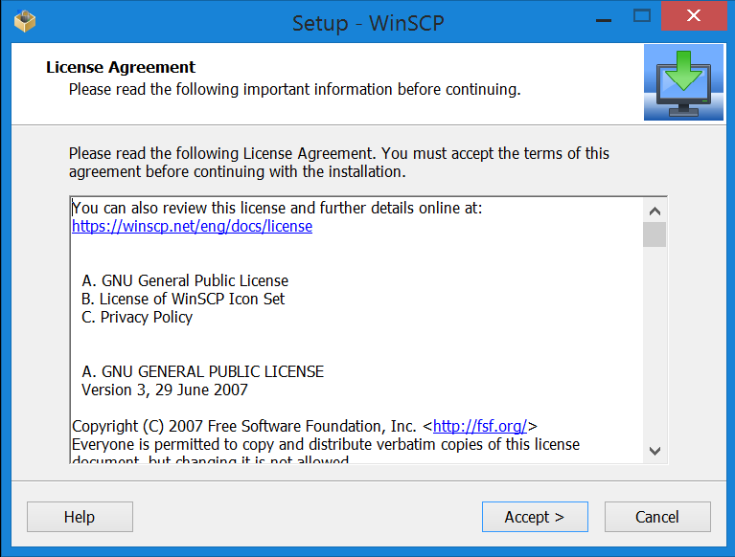

1. Instructions for installing VMD
2. To download the VMD simulator (Visual Molecular Dynamics), visit the University of Illinois site at [**http://www.ks.uiuc.edu/Research/vmd/**](http://www.ks.uiuc.edu/Research/vmd/)

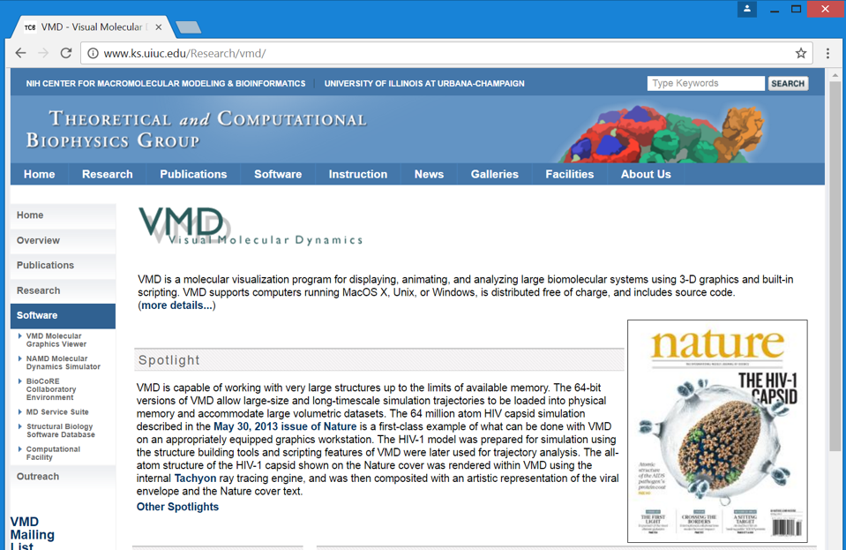

1. Scroll down to the **Download** section and click the link for **VMD 1.9.3 (MacOS X, Unix, Windows)**; this should bring you to the page for the most recent version of the program

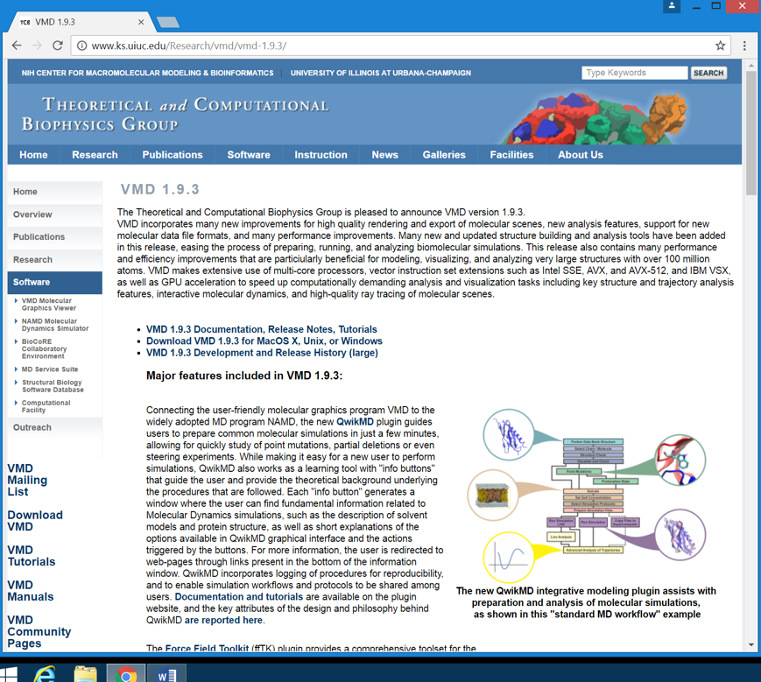

1. Click the second link, **Download VMD 1.9.3 for MacOS X, Unix, or Windows**, then click the appropriate link for your system (e.g. Windows OpenGL for Windows 7, 8, or 10; Mac OS X Open GL for Apple MacOS-X)

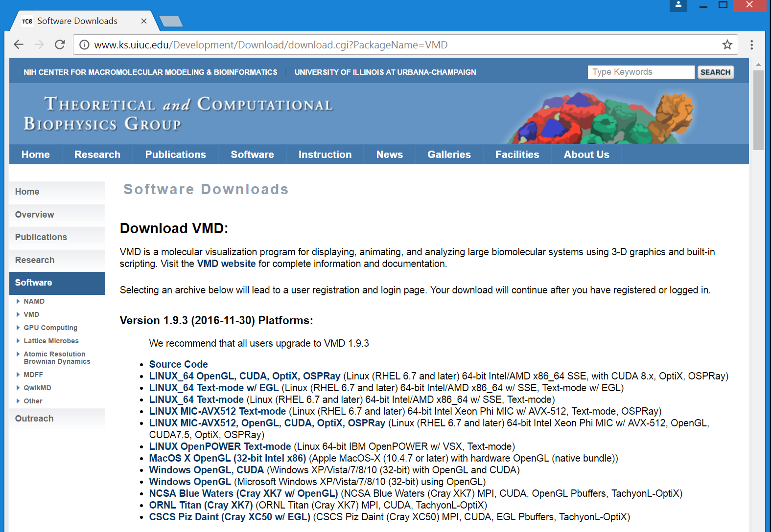

1. At the login screen, enter a username and password of your choosing and click ‘**Continue with registration or download**’

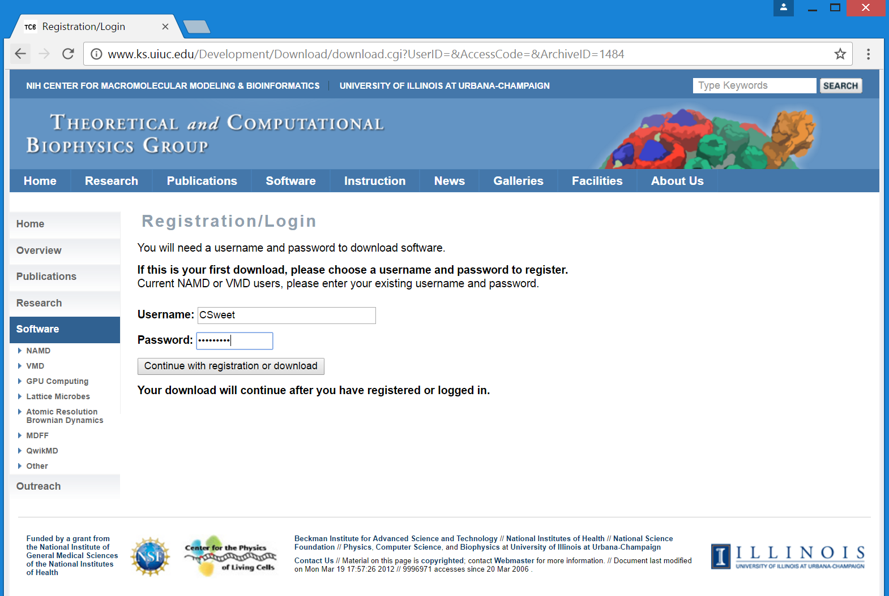

1. Fill out the registration form and press ‘**Register**’

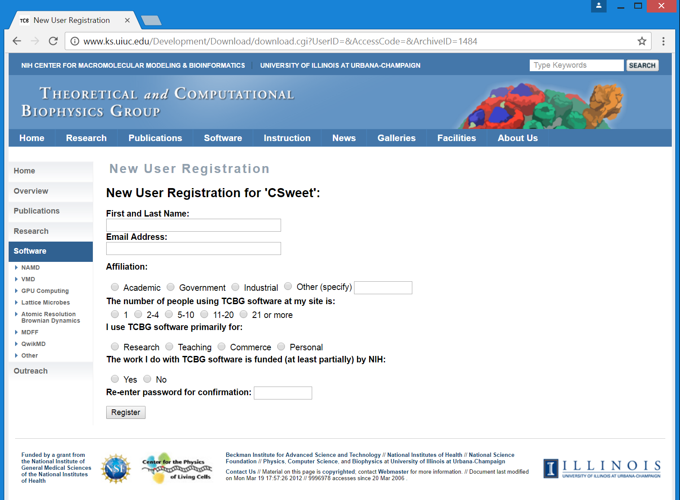

1. Click **‘Save Cookie’** at the top of the page to avoid logging into the site for a six-month period; press the License agreement acceptance button at the bottom of the page

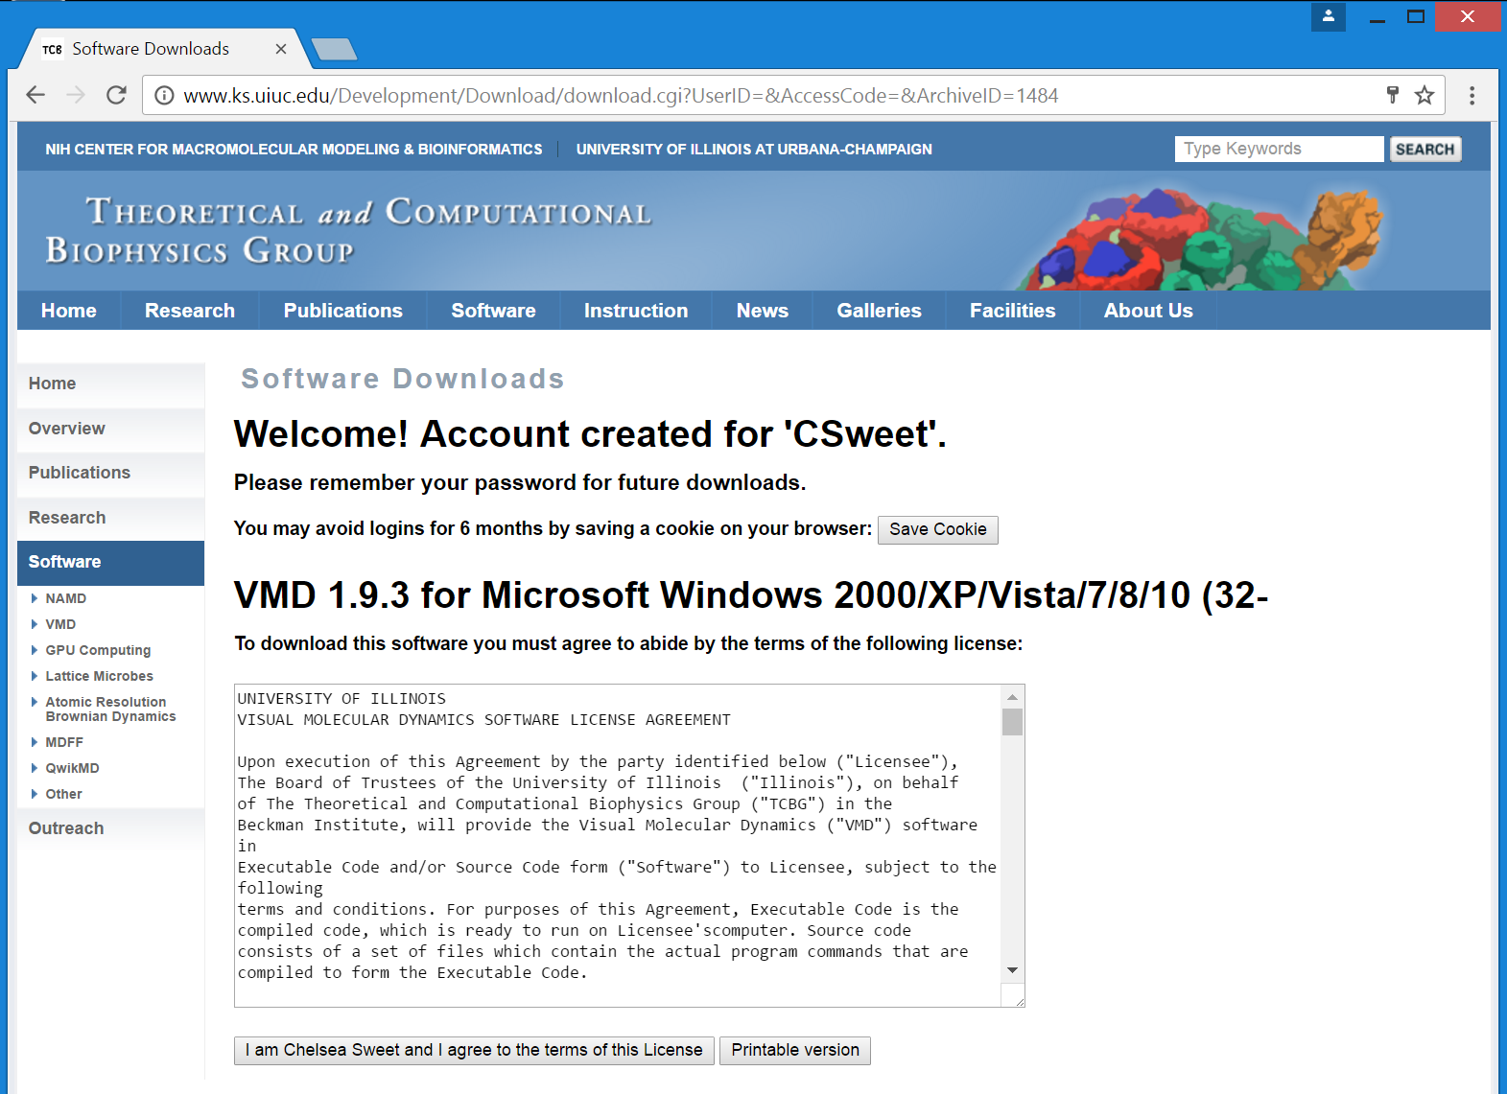

1. (**Windows Users)** Follow the prompts on the install wizard to complete the setup of VMD

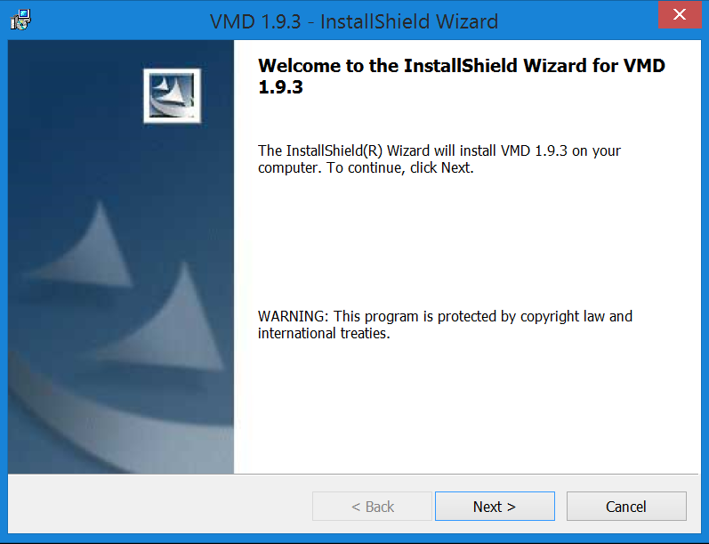

1. **(Mac Users)** In order to download VMD you may need to allow the download in settings. Go to the Apple icon in the left upper corner and open system preferences. 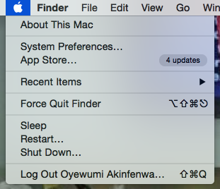
2. Open “security & privacy”. You will click the lock and enter your computers password to make changes. Allow apps to download from anywhere and select “allow from anywhere”. Lock to prevent further changes. **Once download of VMD is opened, change settings back to “Mac App Store and identified developers” to secure your computer.**

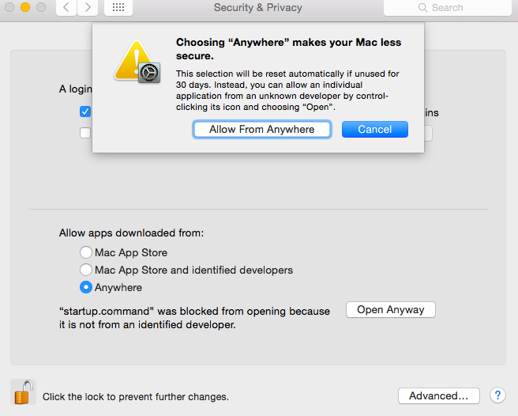

1. Launch the VMD program; three windows will open; the **Open GL Display** is where the simulation video will play and **VMD Main** is where the visual display can be controlled (molecule shape, rewind, pause, etc.)

